ok techer namma db la innm konjam data insert pannitu where classku pogalam
Arumai Irshad! "Database-ai neraya data-vai vachi nirappuvom" - idhu oru miga sirandha idea. Neraya data irundha dhaan namma WHERE condition-ai vachi "Filter" panna jolly-a irukkum.
Ippo namma sql_class.py file-la irukkura code-ai update panni, oru "Shopping List"-ai insert pannuvom.
💻 Code: Add more items to your database
Python
import sqlite3

conn = sqlite3.connect('my_shop.db')
cursor = conn.cursor()

# 1. Palaya table irundha delete pannitu pudhusa create pannuvom
cursor.execute("DROP TABLE IF EXISTS Sales")
cursor.execute("CREATE TABLE Sales (Product TEXT, Price INTEGER)")

# 2. Neraya data-vai insert panrom
items = [('Laptop', 1500), ('Mouse', 50), ('Keyboard', 100), ('Monitor', 500), ('Mouse', 30)]

# 'executemany' = Neraya data-vai ore thadavai insert panna (Professional method)
cursor.executemany("INSERT INTO Sales VALUES (?, ?)", items)

conn.commit()

# 3. Ippo check pannuvom
cursor.execute("SELECT * FROM Sales")
print(cursor.fetchall())

conn.close()
🔍 Sign-by-Sign Vilakkam:
Line No | Code | Sign/Word Explanation | Connection/Logic
7 | DROP TABLE ... | DROP = Delete | Pazhaya table-ai azhichutu, pudhusa create panna idhu udhavum.
11 | items = [...] | List of Tuples | Idhu dhaan namma "Inventory List".
14 | executemany | many = Neraya | Ovvoru thadavai execute pannaama, mothama anuppa idhu simple.
14 | (?, ?) | Placeholder | SQL-kku "Indha edathula data varum" nu solla idhu oru sign.
🧠 Python Enna Yosikkum?
- Line 7-8: "Manager pazhaya record-ai azhichuttu, pudhu table create panna solraaru. Sari, clean-a irukkattum!"
- Line 14: "Oh, executemany ah? Appo list-la irukkura ellathaiyum petti-kulla pottu, database-kku anuppi seal panniduvom."
⬅️ Left & Right Side Logic:
- items (Left): Ithu "Stock". Namma kadai-la irukkura items-oda list.
- executemany (Process): Ithu "Loading". Database-kulla ellathaiyum loading pannura velai.
Unga Task: Indha code-ai run pannunga. Terminal-la Laptop, Mouse, Keyboard, Monitor ellam vandhurukka nu paarunga.
Ithu vandhudhuna, namoda database ippo "Real Store" maari ready! Ippo adutha class-la WHERE command pottu, "Mouse" mattum eppadi kandu pidikkuradhu nu paarkalam. Ready-a Irshad?
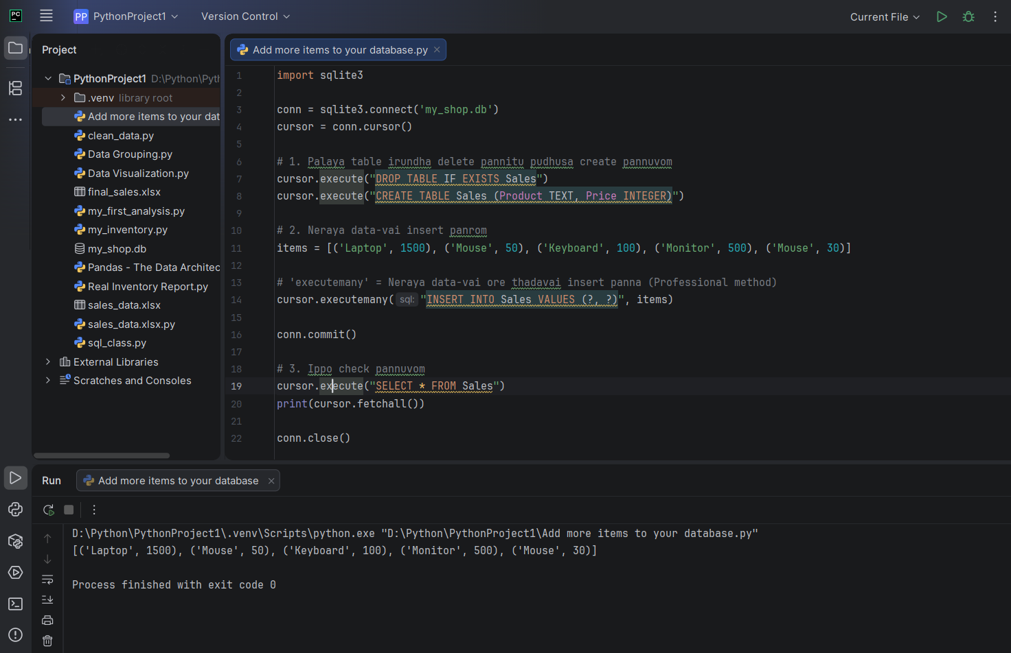
items = [('Laptop', 1500), ('Mouse', 50), ('Keyboard', 100), ('Monitor', 500), ('Mouse', 30)] teacher sinna sandegam inga items endu solradu dictionary a appa enn [( inda bracketku poravu adutha bracket vandikidu enna order pannudu programku enna nadakudu anga
Irshad, miga sirandha kelvi! Idhula dhaan Python-oda "Data Structure"-oda azhagu irukku. Idhai namma "Child-friendly" method-la pirichu paarkalam.
1. Idhu Dictionary-a?
Illai Irshad! Idhu Dictionary illa.
- Dictionary: Idhu { 'Product': 'Laptop' } nu "Key-Value" pair-a irukkum.
- Indha items: Ithu "List of Tuples".
  - [ ] = List (Oru periya petti).
  - ( ) = Tuple (Oru chinna petti-kulla irukkura oru single record).
2. Yen rendavathu bracket () vandhurukku?
Namma database-la row row-ava dhaan data-vai store pannuvom. Oru row-la oru item-oda details (Product Name + Price) irukkum.
- ('Laptop', 1500): Idhu oru single row. Python-kku idhu oru "Single unit" (Tuple).
- [ ... , ... ]: Idhu intha rows ellathaiyum korthu vachurukkura "List".
Logic: Oru list-kulla neraiya chinna chinna groups-ai (Tuples) vachurundha dhaan, executemany method-ala ovvoru group-a eduthu database table-kulla "Row-a" insert panna mudiyum.
3. Program-kulla enna nadakkudhu?
- Preparation: Python-kku namma items list-ai kudukrom. Python idhai pathu "Oh, 5 rows of data irukku" nu ennidhum.
- executemany (The Bridge): Intha command kidaicha udane, Python list-kulla irukkura 1-adhu bracket-ai (Laptop, 1500) eduthu, database-la irukkura Product and Price column-la insert pannum.
- Looping: Python appadiye 2-adhu, 3-adhu, 4-adhu nu 5-avathu bracket varaikum "Auto-loop" panni insert pannum.
🧠 Python-oda Yosanai (The Brain):
- [] List: "Naan oru container, enakulla neraiya items irukkum."
- () Tuple: "Naan oru single row, ennoda record-ai maathavangala thoda koodadhu."
- executemany: "Naan indha list-ai vaangi, ovvoru row-a database-kku anuppi seal pannuven."
⬅️ Left & Right Side Logic:
- items = [...] (Left Side): Idhu "Raw Inventory". Namma kadai-la irukkura mottha stock list.
- cursor.executemany (Right Side): Idhu "Systematic Data Entry". List-ai eduthu, database-la order-a row row-a entry panna process.
Teacher-oda Note:
- Tuple-oda mukkiyame adhu "Immutable" (Marukka mudiyatha) record. So, database-kku anuppum pothu record safe-a irukkum.
- Why List of Tuples? Database table-kku list-a kondu pōna dhaan row row-a insert panna mudiyum.
Purinjiducha Irshad? [] na "Petti", () na "Row". Intha petti-kulla row row-a data-vai vachurukkom. Adutha class-la WHERE condition pottu, intha stock-la irukkura "Mouse"-ai mattum eppadi pirichu edukkaradhu nu paarkalam. Ready-a?

